**DESIGN AND IMPLENTATION OF AN AUTOMATIC CONTROL FOR WATER**

**PUMPING MACHINE USING ULTRASONIC SENSOR (IOT BASED)**

**BY**

**AMUCHE Idolotewonor Kaiser**

**AAU/SPS/FET/ELE/M.Eng/17/10683**

**DEPARTMENT OF ELECTRICAL AND ELECTRONICS ENGINEERING,**

**FACULTY OF ENGINEERING AND TECHNOLOGY,**

**AMBROSE ALLI UNIVERSITY,**

**EKPOMA, NIGERIA.**

**JULY, 2023**

**DESIGN AND IMPLENTATION OF AN AUTOMATIC CONTROL FOR WATER**

**PUMPING MACHINE USING ULTRASONIC SENSOR (IOT BASED)**

**BY**

**AMUCHE Idolotewonor Kaiser**

**AAU/SPS/FET/ELE/M.Eng/17/10683**

**B.Eng. (Benin), MNSE**.

**A THESIS IN THE DEPARTMENT OF ELECTRICAL AND ELECTRONICS**

**ENGINEERING, SUBMITTED TO THE SCHOOL OF POSTGRADUATE STUDIES,**

**IN PARTIAL FULFILMENT OF THE REQUIREMENTS FOR THE AWARD OF**

**MASTERS DEGREE (M.Eng) IN CONTROL / INSTRUMENTATION,**

**FACULTY OF ENGINEERING AND TECHNOLOGY, AMBROSE ALLI**

**UNIVERSITY, EKPOMA, NIGERIA.**

**JULY, 2023**

i

**DECLARATION**

I hereby declare that this research work was done by AMUCHE, Idolotewonor

Kaiser and to the best of my knowledge, this research work has not been submitted

elsewhere for the award of Masters of Engineering or any other degree or diploma.

…….……………………………… ….………………………………..

**AMUCHE, Idolotewonor Kaiser Date**

AAU/SPS/FET/ELE/M.ENG/17/10683

ii

**CERTIFICATION**

This is to certify that this study was carried out by Amuche, Idolotewonor Kaiser

with Matriculation number AAU/SPS/FET/ELE/M.ENG/17/10683, in the Department of

Electrical and Electronics Engineering, Faculty of Engineering and Technology, School of

Postgraduate Studies, Ambrose Alli University, Ekpoma.

……………………………..… ………………………

**Engr. Dr. Okundamiya, M. S. Date**

Supervisor

Department of Electrical and Electronics Engineering,

Faculty of Engineering and Technology,

Ambrose Alli University,

Ekpoma, Nigeria.

……………………………..… …………………..

**Engr. Dr. Okundamiya, M. S. Date**

Head of Department

Department of Electrical and Electronics Engineering,

Faculty of Engineering and Technology,

Ambrose Alli University,

Ekpoma, Nigeria.

....................................... .............………

External Examiner **Date**

iii

**DEDICATION**

This research is dedicated to God Almighty for giving me life and strength to come this far in my

studies. To Him be all the glory.

iv

**ACKNOWLEDGEMENT**

I wish to express my profound gratitude and appreciation to God for His unfailing love and care in sustaining my life, to Him be all the glory, honour and adoration forever and ever. I sincerely thank my supervisor, Engr. Dr. M. S. Okundamiya, for his immerse contribution during this programme. I also thank Engr. Dr. O. Omorogiuwa for his concern, support and encouragement during the programme. Similarly, Engr. Proff. A.M. Obiazi was also of great support. God bless you Sir.

Very warm appreciation goes to all staff of the Department of Electrical and Electronics Engineering for their support in one way or the other to the successful completion of this programme.

I also acknowledge my immediate family, Parents and Siblings for their moral support throughout the programme. My friends and classmates are not left out. I appreciate you all.

v

**ABSTRACT**

Majority of the earth’s surface is covered with water but less than 5% is useful. So water conserving has become a major issue so certain water management steps are to taken. Measuring water level is an important task from government and residence side. Thus, existing management systems has to be updated [1]. In this paper, I investigated the water level management using ultrasonic sensor which detects the amount of water present in the tank and returns the percentage of water present in it.

This system has an Arduino, motor pump, LCD display, overhead tank, reservoir buzzer and an LED. All components are interfaced with the Arduino and works by automation as per uploaded code. I divided the overhead tank by 10%, 20%, …... 100%. 10% is the condition of the tank where the quantity of water present it is very less and finally 100% is maximum condition. We have to monitor and maintain the tank when the water in it is getting less, but in this we make use of a buzzer so whenever the water level percentage is about 10%, the buzzer, makes sense and automatically the relay based motor pump starts and standstill up to reach of 100% of the tank. So no one is required to monitor the tank and for switching of the motor. The main thing I employed is echo, which can be easily understood. Like the sensor has two openings unit. In which one opening sends the high frequency sound pulse called as ultrasonic waves like a small speaker (sender) and the other opening receives them like a small microphone (receiver) [2]

vi

**CONTENTS Page**

DECLARATION ii

CERTIFICATION iii

DEDICATION iv

ACKNOWLEDGEMENT v

ABSTRACT vi

CONTENTS vii

LIST OF TABLES viii

LIST OF FIGURES ix

LIST OF ABBREVIATIONS x

CHAPTER ONE: INTRODUCTION 1

1.1 Background to the Study 1

1.2 Statement of the problem 2

1.3 Objectives of the Study 3

1.4 Scope of the Study 4

1.5 Research Methods 4

vii

1.6 Significance of the Study 4

1.7 Arrangement of the thesis 5

CHAPTER TWO: LITERATURE REVIEW 6

2.1 Overview of Water level detection system 6

2.2 Components of a water level control system 7

2.3 Proteus Simulation Software 9

2.4 State of the Art Assessment of the water level system technology 12

CHAPTER THREE: MATERIALS AND METHODS 17

3.1 Design and Analysis 17

3.1.1 Power Supply Unit 18

3.1.2 Transformer Selection 19

3.1.3 Selection of Bridge Rectifier 25

3.1.4 Capacitor Selection 26

3.1.5 Voltage Regulator Selection 28

3.1.6 The display unit 29

3.1.7 HC – SR04 Sensor unit 30

3.1.7 Aduino Nano controller 32

3.1.8 Micro-controller Unit 32

3.1.9 IOT unit 33

3,2.0 Switch unit 34

3.2.1 Selection of relay 35

3.2.2 Operational Strategy 36

3.2.3 Simulation 37

3.2.4 Fabrication 38

viii

CHAPTER FOUR: RESULTS AND DISCUSSION 40

4.1 TESTS AND RESULTS 40

4.2 Construction of Mechanical Structure (Casing) 41

4.2 Cost Analysis 44

4.2 Findings 46

4.3 Contribution to Knowledge 46

CHAPTER FIVE: CONCLUSION AND RECOMMENDATION 47

5.1 Conclusion 47

5.2 Recommendations 47

REFERENCES 53

APPENDIX A: Overview of Arduino Core Processor 54

APPENDIX B: Specifications for Ultrasonic Sensor 58

APPENDIX C: Micro-controller source code 59

APPENDIX D: Bill of Engineering Measurement and Evaluation 62

**LIST OF TABLES**

Table 4.1: The Cost of Material 49

**LIST OF FIGURES**

Figure 3.1: Schematics of the Water level detection system 22

Figure 3.2: Bridge Rectifier 25

Figure 3.3 Schematic diagram of LCD screen 29

ix

Figure 3.4 Pinout of Ultrasonic sensor 32

Figure 3.5 Circuit diagram of micro controller unit 33

Figure 3.6 Complete circuit diagram of the water level detection system 36

Figure 3.7: Screenshot of the Proteus ISIS 38

Figure 4.2: Graphic Drawing of the water level detection system 42

**LIST OF ABBREVIATIONS**

IC Integrated Circuit

IOT Internet of Things

LCD Liquid crystal display

LED Light emitting diode.

MCU Micro controller unit

PCB Printed circuit board

PIV Peak inverse voltage

ADC Analog to digital converter

POT Potentiometer

x

**CHAPTER ONE**

**INTRODUCTION**

**1.1 Background to the Study**

Water is a common chemical substance that is most essential to man for survival as it forms an average of 60% of the human body (Benelam & Wyness, 2010; Jequier & Constant, 2010; Popkin, et al., 2010). Although water forms a larger mass of the earth, it is not readily available to man for use as a result of its composition and distance from place of necessity (Ikponmwosa & Charles, 2013). This has led to efforts to store and retrieve it when needed by the development of various water storage schemes or systems such as dams, reservoirs, wells, artificial lakes, etc., which engage the use of an electric pump to aid its transportation during storage and retrieval (Maurice & Shona, 2007; Vikram, et al., 2009; Bouarfa et al., 2006). Water is pumped from its source (lower surface) to where it is stored and treated (higher surface) after which it is distributed to where it is needed.

The use of electric pumps to pump water from a source to where it is needed and during retrieval was successful but did have a number of shortcomings which reflected in the challenges of achieving high energy efficiency and extended lifespan of the pump by controlling when to pump, when to stop pumping and how to monitor the level of water in a storage tank (Chaiko et al., 2008; Wara et al., 2007). Human intelligence (which in this particular case is highly unreliable, costly, inefficient and prone to errors) was employed to address these issues. However, this led to wastage of human resources as well as the inefficient maximization of the performance and life span of the electric pump (Ikponmwosa & Charles, 2013). Putting a check to these issues will require an improved operation of the electric water pump which has led to the design and development of several electric water pump controllers.

This project “Design and Implementation of an Automatic Control for Water Pumping Machine” is meant to address the challenges arising from the shortcomings related to the use of electrical water pumps which are manually controlled and also help to eliminate the cost and inefficiency of human interference associated with monitoring and controlling the pump while maximizing the performance and life span of the electric water pump.

1

The system provides an automatic control for an electric water pump so as to refill the tank once the water gets to the lower threshold, while cutting off power supply to the pump once the liquid gets to the higher threshold. In general, this automatic water pump control system makes provision for the control of the water pumping machine and monitoring the level of water in the tank to ensure the continuous flow of water round the clock without the stress of going to switch the pump ON or OFF, thereby saving time, energy, and water wastage.

**1.2 Statement of the problem**

Consider the fact that water is not readily available to man for use as a result of its distance below the earth surface, there is need to retrieve it from its source and store so that it can be available for use. To achieve this, systems need to be in place to ensure that the water is retrieved from the source and transported to the storage tank and ensure that water is always available for use without any human interference.

Momin, Roy, Kader, Hasan, and Islam (2016) designed a digital water level indicator with automatic water pump controlling system which monitors the state of water level whether it is stable, increasing or decreasing with what velocity. It also stores the total time of pump being kept ON and monitors the working performance of the pump. A microcontroller is used to control the overall system automatically that reduces the design and control complexity. It takes input from the sensor unit which senses the water level. After processing input variables, resultant output decides the water pump’s action (on/off) with respect to current water status of the tank. Water level indicator system are quite useful to reduce the wastage from any reservoir, while filling such reservoir. Therefore, this design is a big boom as concerned with the household application as well as other saving purposes including agricultural sector and industries and has an increasing demand and a good aspect from electronic perspective.

2

Pathan et al. (2016) developed an automatic control of a pump system for water level to deploy computing techniques in creating of wastage to help the environment and water cycle which in turn ensures water is saved for the future. It uses a microcontroller and LabVIEW software to automate the process of water pumping in an over-head tank storage system, which has the ability to detect the water level in a tank, switch on/off the pump and display the status on an LCD screen. At the household level, people switch on the water pumps and set off to work or even fall asleep, forgetting to switch off the mains when the tank or reservoir is full. This results to wastage often flood. Hence, this design was successful for two levels (low and high levels) in a tank, where closed loop system has been implemented.

Jamal (2016) worked on logical automatic water control system to terminate the water pump from over flow and also show indication at different levels of water in overhead tank. This design is based on the concept of electric conductivity of water, which has its own power supply and solar power back up system that provides continuous electric supply in case of load shedding which is common in many countries. It operates on 5V dc. This system is very efficacious to overcome the water crisis in the world and it is very effective and sound than tradition method which includes mechanical floating probe methods. It is cheaper and durable.

Oloyede (2017) developed microcontroller-based water pumping machine aimed at reducing water wastage and pump failures, due to not switching it off immediately when not needed. The control system from which water level of both tanks are observed with simultaneous water pump control is based on existing water level technology using the principle of ultrasound for level sensing. It provided an improvement on existing water level controllers by its use of calibrated circuit to indicate the water level and use of DC instead of ac power, thereby eliminating risk of electrocution. The developed system is capable of powering a 1hp pump from the input voltage, which can deliver an output current up to 20A. The system will help to eliminate the cost and inefficiency of human interference associated with manual monitoring and controlling of pump, while maximizing the performance and life span of the electric water pump.

3

The system was designed as an attempt to eliminate the unreliability of humans, indicate the level of water in the tank and to improve the workable life of the pump by increasing its mean time to fail due to reduction of the stress on it, thus enhancing the electric pump’s overall performance.

Prima, Munifaha, Salam, Aziz, and Suryani (2017), designed an automatic water tank filling system for home application by applying an ultrasonic sensor, an automatic switch module, a water-flow sensor, an Arduino TM microcontroller, and a pumping machine in order to automatically switch the water filling. The Indonesian villagers commonly supply the water by pumping the groundwater to fill a water tank. However, the utilization of non-automated switch used to turn on and turn off a pumping machine sometimes causes either the water spills or a wasteful electrical consumption. With this system, people will enjoy supplying water without their worries related to water spills and a wasteful electrical consumption.

Ruan, Ma, Lv, Liu, and Zhang (2017), studied and designed an automatic speed control system of a pneumatic submersible pump to automatically adjust the pressure and flow of the submersible pump under no-load and load conditions and to simulate the stability of the system with Advanced Modelling and Simulation Environment for Systems Engineering (AMESim). The water supply at the pumping end of the submersible pump is sporadic with frequent no-load operation given the low water levels in most rural canals during summer. The change in water flow and pressure directly causes high turbine speed and thus leads to the runaway speed phenomenon, which seriously affects operational safety. This control system solves the problem of runaway speed and realizes automatic speed control of the pneumatic submersible pump under the no-load condition.

Deb et al. (2018), designed and implemented a Wireless Pump Control with Water Level Monitoring System in order reduce the wastage of two essential resources energy and water as well as to save time with the rise in population demands for them. This automated water pump designed, involves cheap electronic devices like RF module, relay, PV cell etc.

4

The pump works on renewable power source i.e., solar energy and includes an automated water level indicator which indicates the water level at various stages, being full, empty and middle.

Thus, in the processes switching on the pump when the tank is empty and switching the pump off when the tank gets full so that no water is wasted and the whole system is wireless.

Gagandeep, Arora, and Saini (2018), designed and implemented an automatic irrigation system based on monitoring soil moisture. One of the objectives of this work is to see how human control could be removed from irrigation and also to optimize the use of water in the process. The method employed is to continuously monitor the soil moisture level to decide whether irrigation is needed, and how much water is needed in the soil. A moisture sensor was constructed to model the electrical resistance of the soil; a regulated 12volts power supply unit was constructed to power the system; the control circuit was implemented using operational amplifier and timer; and the pumping subsystem consisting of a submersible low-noise micro water pump was constructed using a small dc-operated motor. The system was tested on three types of soil and from the result analysis sandy soils require less water than loamy soils and clay soils require the most water for irrigation.

Biswas and Iqbal (2018), worked on Dynamic Modelling of a Solar Water Pumping System with Energy Storage used for extraction of groundwater for irrigation using an alternative source of energy. The system is designed based on data of an existing project in Lalmonirhat, Bangladesh. The system comprises a 38.4kWp solar photovoltaic array, inverter, AC motor, and pump set, which can discharge a maximum of 1,930m3 of water per day. MATLAB simulation is performed with two types of energy storage system: (i) electric energy using a battery bank and (ii) stored water in a large water tank. The main objective of this paper was to develop dynamic models for both battery-less and battery-based system to run a motor-pump set using solar energy to lift ground water for irrigation purpose. This project indicates that the solar water pumping system can be integrated to irrigation systems in Bangladesh as it is feasible solution for longer period. For twenty-five years of life cycle, solar PV system will cost half of the diesel engine operated system.

5

Nasir, Alkhadafe, and Mohammed (2018), designed and implemented water level monitoring and controlling system, which aims to overcome issues that may present as a result of using manual systems for filling up domestic water tanks, such as, flooding of water in residential areas, which leads to the decline in roads and disruption of traffic, waste of energy, an increase in the noise pollution caused by the sound of the pumps and lack of water available in the network. It is based on PIC microcontroller and Sharp infra- red range sensor. The advantages of this system include: saving energy, reduce noise, optimization of water regulation and improve the lifespan of the pumps duo to working automatically.

Islam and Amjad (2018), developed an automatic system based on Android application which monitors the water pump and checks the water level in the agricultural land. It leads farmers to apply the right amount of water at the right time and turn the water pump ON and OFF without using labour. It also helps to save time and reduces human errors by adjusting available soil moisture levels, which increases their net profits. But manual water pump controller system wastes a lot of water everyday around the world. Whereas, the automated water pump controller system using an Android mobile application reduces human effort and wastage of time. It also results in billing of water, usage in households, agricultural land, industries, hotel etc.

Khairunnas, Ariyanto, and Prabowo (2018), designed and Implemented a Smart Bath Water Heater using Arduino in order to turn on the water heater without having to be in the location of water heater, which is to turn the water heater from a distance. Most people want to take a bath with the desirable water temperature to get more comfort level when bathing. In this system has been designed an automatic faucet that can be active in accordance with the temperature of water that is in the main tub with the help of temperature sensors, ultrasonic sensors and water pumps. Both sensors utilize a machine-to-machine system with MQTT protocols controlled by an Arduino Mega2560-based Android microcontroller. From the temperature performance test results, the temperature accuracy for the system is 97.60% with the average time required to complete the system is 18 minutes 30 seconds, with the volume of main tub to be filled is ± 9.240 cm3, and the volume of water available on a hot tub is ± 12.320 cm3.

6

Godwin Premi and Malakar (2019), designed an automatic water tank level and pump control system. Scarcity of water is one of the biggest issues revolving across the globe and water crisis is reaching the alarming level day by day. So, water conservation in one or the other way is gaining a significant importance. Mostly, nowadays in urban as well as in rural areas water tank system is available. Hence, in this work, it is tried to design an automatic water tank level and pump control system, which ensures several benefits. The objectives defined for the system are to design an automatic water tank level mechanism and to control the level of water quantity in the tank, display the state of pump, levels of water and also the level of main tank etc. The water level detecting sensor used is an ultrasonic sensor which is mounted on the storage tank and the controller used is Arduino Uno for automating the mechanism of pumping water to the overhead storage tank. The model is designed in such a way that it saves electricity, cost, and mostly reduces the traditional water overflow challenges.

Saha, Mukherjee, Roy, and Chatterjee (2019), designed and implemented an Electrical Water Pump Controller and Level Indicator (EWPCLI) to exploit the electrical conductivity of water to give indication of water level in a storage tank and ultimately, the automatic control of the water pump. It employs a number of metallic conductors or probes, each positioned at separate levels along the tank height to act as sensors. Comparators monitor the presence of water at the probes (utilizing the conductivity of ionized water due to its impurities) and give out corresponding digital outputs which are used by the microcontroller to drive digital outputs which turn on visual display LEDs that indicate various water levels in the tank. Its aim is to control the motor automatically as well as reduces human effort. The system will help to eliminate the cost and inefficiency of human interference associated with monitoring and controlling the pump while maximizing the performance and life span of the electric water pump. But its constraint is that the metallic conductors inserted in the tank can contaminate the water due to rust.

7

Kolesnikov, Shprekher, and Malkov (2019), developed an Automated System Ensuring Uninterrupted Water Supply for Small Settlements using a controlled electric drive based on the frequency converter as a backup – contactless thyristor starter, powered by mains voltage, and diesel generator. Its main objectives are to eliminates the cost of replacement or reconstruction of the tower and has a number of undeniable technical advantages over the water supply system with a water tower. The developed automated system ensures uninterrupted water supply to consumers, increases energy efficiency and reliability of power module PM to the motor of the submersible pump and the continuous monitoring of the frequency drive of a submersible pump ensures timely detection of violations of the mode of operation and emergency situations.

Lestariningsih, Artono, Hidayatullah, and Kusbandono (2019), designed a Microcontroller and Android HMI Based Water Level and Control System aimed at in controlling and monitoring water level in a reservoir automatically using an Android smartphone so that it can be controlled remotely to complement the shortcomings of previous research, a Node MCU ESP8266 Microcontroller, a relay module that functions to turn on and turn off the pump, and one sensor, the HC-SR04 Ultrasonic Sensor which functions to measure the water level in the reservoir. The test result data is shown in the cayenne application (Android application) in the form of setting the water height set point, the ON / OFF pump indicator and the height value in units of percent (%) and centimetre (cm).

Zhang, Wang, Li, and Zhang (2019), introduced the design method of monitoring system for oil-gas-water multi-phase flow. The oil-gas-water multi-phase flow control system of this paper designed consists of host monitor and slave machine. The S7-200 PLC has been developed by the slave machine to control the valve opening and pumps’ start and stop, accomplish sensors data collecting and processing. The host monitor selects King view software to develop monitoring interface. The host monitor communicates with the slave machine by serial port. The results show that most flow patterns can be easily regulated and realized, have high reliability and high portability as well as provides experimental conditional for the research of oil- gas-water multi-phase flow theory and the development of monitoring equipment.

8

Prakosa, Putov, and Stotckaia (2019), designed a Closed Loop Control System for Water Flow Rate built on the basis of microcontroller equipment to regulate the flow rate through pump. Hall Effect flow meter sensors are applied as the feedback elements to measure water flow rate, control algorithms for actuating signals, and actuators which attempt to regulate the error to close to zero and make some variables equal to desired values. The aim of this research is to investigate the measurement uncertainty of closed loop control system on water flow rate application. The optimal gain signal is obtained by 0.5 which has the smallest measurement uncertainty around 2.1% at point of (444.0±9.2) ml/min. The closed loop control system for water flow rate has been successfully developed. The average expanded uncertainty achieved is 2%.

OO (2020), designed, simulated and implemented an Arduino microcontroller based automatic water level controller with I2C LCD display. This project will allow the level of water in a tank to be maintained automatically, that is, unattended to; it uses Arduino microcontroller, codes were written in order for it to perform as water level controller. Proteus was used to simulate the design while the project was implemented on breadboard. The result has helped to solve problems of manual operations of water pumping system and succeeded in highlighting the simplicity of using Arduino Microcontroller in the designs of Power Electronic systems. In order to prolong the life of the pump, a Direct- on-Line starter could be engaged in starting it.

Karar, Al-Rasheed, Al-Rasheed, and Reyad (2020), developed an IoT and Neural Network-Based Water Pumping Control System aimed at saving the wasted water in the process of irrigation using the Internet of Things (IOT) based on a set of sensors and Multi-Layer Perceptron (MLP) neural network. The developed system handles the sensor data using the Arduino board to control the water pump automatically. The sensors measure the environmental factors; namely temperature, humidity, and soil moisture to estimate the required time for the operation of water irrigation.

9

The water pump control system consists of software and hardware tools such as Arduino Remote XY interface and electronic sensors in the framework of IoT technology. The developed irrigation system supports the farmers to save wasted water, time and effort to increase the productivity of their crops.

Mohd, Hikmah, Azizan, Elfadil, and Pahang (2020), designed and developed a Microcontroller Based Automatic Fish Feeder System to determine the volumetric of food required depending on the types of fish as well as a water quality monitoring system to keep the fishes in good condition for their growth implemented on a Node MCU microcontroller, which contains built-in Wi-Fi module. The developed system enabled the fish owners to monitor their fish tanks for correct functioning of the fish feeder as well as to set schedules for feeding the fish and monitoring of water quality by utilizing pH sensor and turbidity sensor.

Gesa (2020), researched on and developed a wireless microcontroller-based fluid level display system using ultrasonic sensing method to monitor fluid level/content in most fluid systems such as opaque containers and closed systems such as overhead tanks. This entails the assembling of components such as ultrasonic sensors, transistors, radio frequency transmitters and receivers with a microcontroller interfaced to determine, process and display accurately the level of fluid in a container. The system was tested to have maximum sensitivity over a distance of 98.5 meters in non-obstructed areas and 50 meters in obstructed areas. The average response time was also estimated to be 0.5 seconds which is suitable for deployment and usage in domestic and industrial purposes.

Most manually operated water pumping machine are usually switched OFF when the tank is full, and if there is no individual to monitor the system, it can lead to water spillage, flooding, consumption of more power and sometimes damage to water pump. Also, the pumping machine is switched ON when the tank is empty and this can lead to water storage. These switching methods are highly unreliable, not cost effective, reduce lifespan of machine and water wastage/ shortage.

10

This system uses an application that can be installed on any android phone that can be used for real time monitoring of the water level in the tank from anywhere in the world. The Application can also be used to switch – off the pumping machine at any point in time.

**1.3 Objectives of the Study**

The aim of this project work is to design and implement an automatic control for a water pumping machine, a system capable of switching OFF or switching ON the water pumping machine when the water in the storage tank is full or at minimum level.

The specific objectives of the project work are to:

* develop a system that is capable of switching ON/OFF the water pump when the storage tank is filled up and at a minimum level;
* reduce the down time of the pumping machine;
* use a sensing method that has no contact with the water to monitor its level; and
* develop a system that can provide real time monitoring and control using android application.

**1.4 Scope of the Study**

This work is to fabricate, implement / install and analyze the water level system using ultrasonic sensor and sending signal to a microcontroller to either switch ON or OFF the pumping machine.

**1.5 Research Methodology**

To achieve the stated objectives, the following method will be used:

* Design a circuit that will be used to carry out the propose control;
* Develop the circuit and a bread board;

11

* Write a code using C programming language and burn to the microcontroller to enable communication between the sensor and the pumping machine; and
* Construct a prototype that will be used as the test bed

**1.6 Significance of the study**

This study is important because it will help to eliminate the wastage and shortage of water as a result of manual operation of water pumping system. Also, it will help to prolong the life span of water pumping machines.

**1.7 Arrangement of the thesis**

Chapter one discusses the background to the study, statement of the problem, the objectives, overview of research methods and the significance of the study. Chapter two gives a thorough overview of relevant literature applied in the design, simulation and the fabrication of a water pumping machine using ultrasonic sensor. Chapter three describes the design methods, analysis and the experimental set-up of the different methods of connection. Chapter four discusses the construction, testing and results while chapter five gives the conclusion and recommendation of the study. Appendix A gives the overview of the Arduino core processor. Appendix B gives the specification for ultrasonic sensor pin layout, Appendix C gives the software program written using assembly language and appendix D gives the Bill of Engineering Measurement and Evaluation.

12

**CHAPTER TWO**

**LITERATURE REVIEW**

**2.1 Overview of water level automatic control system.**

An IoT water level detector system is a device or set of devices that are used to monitor the level of water in a particular area, such as a tank, reservoir, or aquifer. These systems typically consist of sensors that are placed in the water to measure the level, and a device or system that collects and analyzes the data from the sensors. The data can then be used to trigger alarms or automatic responses, such as shutting off a pump or opening a valve, to prevent flooding or other issues. Additionally, the data can also be sent to a remote location or cloud service for monitoring, analysis, and reporting. These systems can be used in a variety of applications, including industrial, agricultural, and residential settings.

**2.2 Components of water level control system**

The proposed water level control system is made up of an ultrasonic sensor, Arduino controller, HC-05 Bluetooth module, relay uln 2803, power supply. The first components needed is the power supply, which provide energy to power up the system. There are two main types of power supply, which are regulated and unregulated power supply, for this project a regulated power supply was used to help reduced the complexity that is in an unregulated power supply.

The power supply major components are transformer, rectifier, capacitor and voltage regulator.

The transformer helps to step down the input voltage to the system to 12volts and then supply that voltage to the rectifier which then converts the step down AC voltage into DC, the DC voltage is then filtered further by the capacitor and regulated to a useable voltage level of 5v for the Arduino Microcontroller and IOT Bluetooth device to be powered on with.

13

**2.3 Proteus Simulation Software**

The Proteus Design Suite is a simulation tool utilized mainly for the design and automation of electronic systems, to create electronics prints for manufacturing printed circuit boards. Schematic capture in the software can be utilized for designs simulations and for the design phase of a PCB layout project. Proteus is a software tool used for simulating and designing electronic circuits. It includes a library of components and allows users to create and test circuit designs in a virtual environment before building them in real life. Proteus also includes a microcontroller simulation feature, which allows users to write, test, and debug code for microcontroller-based designs. It's commonly used for educational and hobbyist projects, and also used by professionals in industry for testing and designing circuits.

A major advantage of the simulator is that it can provide the user with practical feedback when designing real life systems. This can enable the designer to decide the suitability and efficiency of a design before the actual construction. By examining the impacts of definite design decisions throughout the design phase rather than the construction phase, the overall cost of the system can be reduced significantly (Marques, and Pacheco, 2007).

The advantages of using Proteus Design Software for the simulation include the ability to develop and test a design before a physical prototype is fabricated. Moreover, the simulation tool provides extensive debugging facilities including breakpoints, single stepping and variable display for both assembly code and high level language source (Dweikak, Yazori, Aldaraghmeh, 2012).

**2.4 State-of-the-Art Assessment of water level automatic control System Technology.**

Prakosa, Putov, and Stotckaia (2019), designed a Closed Loop Control System for Water Flow Rate built on the basis of microcontroller equipment to regulate the flow rate through pump. Hall Effect flow meter sensors are applied as the feedback elements to measure water flow rate, control algorithms for actuating signals, and actuators which attempt to regulate the error to close to zero and make some variables equal to desired values. The aim of this research is to investigate the measurement uncertainty of closed loop control system on water flow rate application.

14

The optimal gain signal is obtained by 0.5 which has the smallest measurement uncertainty around 2.1% at point of (444.0±9.2) ml/min. The closed loop control system for water flow rate has been successfully developed. The average expanded uncertainty achieved is 2%.

Ruan,Ma,Lv,Liu, and Zhang (2017), studied and designed an automatic speed control system of a pneumatic submersible pump to automatically adjust the pressure and flow of the submersible pump under no-load and load conditions and to simulate the stability of the system with Advanced Modelling and Simulation Environment for Systems Engineering (AMESim). The water supply at the pumping end of the submersible pump is sporadic with frequent no-load operation given the low water levels in most rural canals during summer. The change in water flow and pressure directly causes high turbine speed and thus leads to the runaway speed phenomenon, which seriously affects operational safety. This control system solves the problem of runaway speed and realizes automatic speed control of the pneumatic submersible pump under the no-load condition.

Deb et al. (2018), designed and implemented a Wireless Pump Control with Water Level Monitoring System in order reduce the wastage of two essential resources energy and water as well as to save time with the rise in population demands for them. This automated water pump designed, involves cheap electronic devices like RF module, relay, PV cell etc. The pump works on renewable power source i.e., solar energy and includes an automated water level indicator which indicates the water level at various stages, being full, empty and middle. Thus, in the processes switching on the pump when the tank is empty and switching the pump off when the tank gets full so that no water is wasted and the whole system is wireless.

Gagandeep, Arora, and Saini (2018), designed and implemented an automatic irrigation system based on monitoring soil moisture. One of the objectives of this work is to see how human control could be removed from irrigation and also to optimize the use of water in the process. The method employed is to continuously monitor the soil moisture level to decide whether irrigation is needed, and how much water is needed in the soil.

15

A moisture sensor was constructed to model the electrical resistance of the soil; a regulated 12volts power supply unit was constructed to power the system; the control circuit was implemented using operational amplifier and timer; and the pumping subsystem consisting of a submersible low-noise micro water pump was constructed using a small dc-operated motor. The system was tested on three types of soil and from the result analysis sandy soils require less water than loamy soils and clay soils require the most water for irrigation.

Momin, Roy, Kader, Hasan, and Islam (2016) designed a digital water level indicator with automatic water pump controlling system which monitors the state of water level whether it is stable, increasing or decreasing with what velocity. It also stores the total time of pump being kept ON and monitors the working performance of the pump. A microcontroller is used to control the overall system automatically that reduces the design and control complexity. It takes input from the sensor unit which senses the water level. After processing input variables, resultant output decides the water pump’s action (on/off) with respect to current water status of the tank. Water level indicator system are quite useful to reduce the wastage from any reservoir, while filling such reservoir. Therefore, this design is a big boom as concerned with the household application as well as other saving purposes including agricultural sector and industries and has an increasing demand and a good aspect from electronic perspective.

Pathan et al. (2016) developed an automatic control of a pump system for water level to deploy computing techniques in creating of wastage to help the environment and water cycle which in turn ensures water is saved for the future. It uses a microcontroller and LabVIEW software to automate the process of water pumping in an over-head tank storage system, which has the ability to detect the water level in a tank, switch on/off the pump and display the status on an LCD screen. At the household level, people switch on the water pumps and set off to work or even fall asleep, forgetting to switch off the mains when the tank or reservoir is full. This results to wastage often flood. Hence, this design was successful for two levels (low and high levels) in a tank, where closed loop system has been implemented.

16

Jamal (2016) worked on logical automatic water control system to terminate the water pump from over flow and also show indication at different levels of water in overhead tank. This design is based on the concept of electric conductivity of water, which has its own power supply and solar power back up system that provides continuous electric supply in case of load shedding which is common in many countries. It operates on 5V dc. This system is very efficacious to overcome the water crisis in the world and it is very effective and sound than tradition method which includes mechanical floating probe methods. It is cheaper and durable.

Oloyede (2017) developed microcontroller-based water pumping machine aimed at reducing water wastages and pump failures, due to not switching it off immediately when not needed. The control system from which water level of both tanks are observed with simultaneous water pump control is based on existing water level technology using the principle of ultrasound for level sensing. It provided an improvement on existing water level controllers by its use of calibrated circuit to indicate the water level and use of DC instead of ac power, thereby eliminating risk of electrocution. The developed system is capable of powering a 1hp pump from the input voltage, which can deliver an output current up to 20A. The system will help to eliminate the cost and inefficiency of human interference associated with manual monitoring and controlling of pump, while maximizing the performance and life span of the electric water pump. The system was designed as an attempt to eliminate the unreliability of humans, indicate the level of water in the tank and to improve the workable life of the pump by increasing its mean time to fail due to reduction of the stress on it, thus enhancing the electric pump’s overall performance.

Prima, Munifaha, Salam, Aziz, and Suryani (2017), designed an automatic water tank filling system for home application by applying an ultrasonic sensor, an automatic switch module, a water-flow sensor, an Arduino TM microcontroller, and a pumping machine in order to automatically switch the water filling. The Indonesian villagers commonly supply the water by pumping the groundwater to fill a water tank. However, the utilization of non-automated switch used to turn on and turn off a pumping machine sometimes causes either the water spills or a wasteful electrical consumption. With this system, people will enjoy supplying water without their worries related to water spills and a wasteful electrical consumption.

17

Biswas and Iqbal (2018), worked on Dynamic Modelling of a Solar Water Pumping System with Energy Storage used for extraction of groundwater for irrigation using an alternative source of energy. The system is designed based on data of an existing project in Lalmonirhat, Bangladesh. The system comprises a 38.4kWp solar photovoltaic array, inverter, AC motor, and pump set, which can discharge a maximum of 1,930m3 of water per day. MATLAB simulation is performed with two types of energy storage system: (i) electric energy using a battery bank and (ii) stored water in a large water tank. The main objective of this paper was to develop dynamic models for both battery-less and battery-based system to run a motor-pump set using solar energy to lift ground water for irrigation purpose. This project indicates that the solar water pumping system can be integrated to irrigation systems in Bangladesh as it is feasible solution for longer period. For twenty-five years of life cycle, solar PV system will cost half of the diesel engine operated system.

Nasir, Alkhadafe, and Mohammed (2018), designed and implemented water level monitoring and controlling system, which aims to overcome issues that may present as a result of using manual systems for filling up domestic water tanks, such as, flooding of water in residential areas, which leads to the decline in roads and disruption of traffic, waste of energy, an increase in the noise pollution caused by the sound of the pumps and lack of water available in the network. It is based on PIC microcontroller and Sharp infra- red range sensor. The advantages of this system include: saving energy, reduce noise, optimization of water regulation and improve the lifespan of the pumps duo to working automatically.

Islam and Amjad (2018), developed an automatic system based on Android application which monitors the water pump and checks the water level in the agricultural land. It leads farmers to apply the right amount of water at the right time and turn the water pump ON and OFF without using labour. It also helps to save time and reduces human errors by adjusting available soil moisture levels, which increases their net profits. But manual water pump controller system wastes a lot of water everyday around the world.

18

Whereas, the automated water pump controller system using an Android mobile application reduces human effort and wastage of time. It also results in billing of water, usage in households, agricultural land, industries, hotel etc.

Khairunnas, Ariyanto, and Prabowo (2018), designed and Implemented a Smart Bath Water Heater using Arduino in order to turn on the water heater without having to be in the location of water heater, which is to turn the water heater from a distance. Most people want to take a bath with the desirable water temperature to get more comfort level when bathing. In this system has been designed an automatic faucet that can be active in accordance with the temperature of water that is in the main tub with the help of temperature sensors, ultrasonic sensors and water pumps. Both sensors utilize a machine-to-machine system with MQTT protocols controlled by an Arduino Mega2560-based Android microcontroller. From the temperature performance test results, the temperature accuracy for the system is 97.60% with the average time required to complete the system is 18 minutes 30 seconds, with the volume of main tub to be filled is ± 9.240 cm3, and the volume of water available on a hot tub is ± 12.320 cm3.

Godwin Premi and Malakar (2019), designed an automatic water tank level and pump control system. Scarcity of water is one of the biggest issues revolving across the globe and water crisis is reaching the alarming level day by day. So, water conservation in one or the other way is gaining a significant importance. Mostly, nowadays in urban as well as in rural areas water tank system is available. Hence, in this work, it is tried to design an automatic water tank level and pump control system, which ensures several benefits. The objectives defined for the system are to design an automatic water tank level mechanism and to control the level of water quantity in the tank, display the state of pump, levels of water and also the level of main tank etc. The water level detecting sensor used is an ultrasonic sensor which is mounted on the storage tank and the controller used is Arduino Uno for automating the mechanism of pumping water to the overhead storage tank. The model is designed in such a way that it saves electricity, cost, and mostly reduces the traditional water overflow challenges.

19

Saha, Mukherjee, Roy, and Chatterjee (2019), designed and implemented an Electrical Water Pump Controller and Level Indicator (EWPCLI) to exploit the electrical conductivity of water to give indication of water level in a storage tank and ultimately, the automatic control of the water pump. It employs a number of metallic conductors or probes, each positioned at separate levels along the tank height to act as sensors. Comparators monitor the presence of water at the probes (utilizing the conductivity of ionized water due to its impurities) and give out corresponding digital outputs which are used by the microcontroller to drive digital outputs which turn on visual display LEDs that indicate various water levels in the tank. Its aim is to control the motor automatically as well as reduces human effort. The system will help to eliminate the cost and inefficiency of human interference associated with monitoring and controlling the pump while maximizing the performance and life span of the electric water pump. But its constraint is that the metallic conductors inserted in the tank can contaminate the water due to rust.

Kolesnikov, Shprekher, and Malkov (2019), developed an Automated System Ensuring Uninterrupted Water Supply for Small Settlements using a controlled electric drive based on the frequency converter as a backup – contactless thyristor starter, powered by mains voltage, and diesel generator. Its main objectives are to eliminates the cost of replacement or reconstruction of the tower and has a number of undeniable technical advantages over the water supply system with a water tower. The developed automated system ensures uninterrupted water supply to consumers, increases energy efficiency and reliability of power module PM to the motor of the submersible pump and the continuous monitoring of the frequency drive of a submersible pump ensures timely detection of violations of the mode of operation and emergency situations.

20

Lestariningsih, Artono, Hidayatullah, and Kusbandono (2019), designed a Microcontroller and Android HMI Based Water Level and Control System aimed at in controlling and monitoring water level in a reservoir automatically using an Android smartphone so that it can be controlled remotely to complement the shortcomings of previous research, a Node MCU ESP8266 Microcontroller, a relay module that functions to turn on and turn off the pump, and one sensor, the HC-SR04 Ultrasonic Sensor which functions to measure the water level in the reservoir. The test result data is shown in the cayenne application (Android application) in the form of setting the water height set point, the ON / OFF pump indicator and the height value in units of percent (%) and centimeter (cm).

Zhang, Wang, Li, and Zhang (2019), introduced the design method of monitoring system for oil-gas-water multi-phase flow. The oil-gas-water multi-phase flow control system of this paper designed consists of host monitor and slave machine. The S7-200 PLC has been developed by the slave machine to control the valve opening and pumps’ start and stop, accomplish sensors data collecting and processing. The host monitor selects King view software to develop monitoring interface. The host monitor communicates with the slave machine by serial port. The results show that most flow patterns can be easily regulated and realized, have high reliability and high portability as well as provides experimental conditional for the research of oil- gas-water multi-phase flow theory and the development of monitoring equipment.

21

**CHAPTER THREE**

**MATERIALS AND METHODS**

**3.0 Design and Analysis**

In this section, the various block/units and their circuit diagrams, design analysis, criteria and assumptions made for component selection are presented. Figure 3.1 shows the functional blocks of the designed circuit.

Power Supply

Display Unit

IOT Unit

MCU

Sensor Unit

Switch Unit

PUMP

Legend

Power

Data

**Figure 3.1:** Schematics of the water level automatic control system

22

**3.1 Power Supply Unit**

The power supply unit is responsible for providing the biasing and operating voltage for the circuit operation. The input to this unit is 220/240VAC at a frequency of 50Hz and the output is 12V DC.

This unit comprises of the following basic components;

* 220/12V step-down transformer
* Bridge diode
* 35V 1000uF and 25V 47uF capacitors
* LM7805 Voltage regulator
* 104Ω Resistors

**3.1.1 Transformer Selection**

The choice of transformer was based on the following;

1. The input voltage range
2. The output voltage range
3. The power rating of the transformer in kVA
4. Operating frequency of power supply
5. The number of turns and the diameter of the transformer coil

The input voltage range from the supply mains is from 220~240V AC single phase supply. The output voltage range of the transformer is from 12~19V AC to the rectifier circuit. The rating of the transformer or the power rating of the transformer is 1kVA. This indicates that the capacity of the circuit is 1kVA.

Total current of the circuit is given by:

Current demand by voltage regulators + current demand by Arduino Nano + current demand by display unit (LCD) + current demanded by relay + current demanded by relay driver + current demanded by HC-06 + current demanded by Ultrasonic sensor

23

Where Current demand by voltage regulator = 8mA

Current demand by Arduino Nano = 3.6mA

Current demand by display unit = 4.8mA

Current demand by relay unit = 3.8mA

Current demand by relay driver = 12.8mA

Current demand by HC-06 = 3.8mA

Current demand by Ultrasonic Sensor = 4.8mA

∴Total current of the circuit, IL = 8mA + 3.6mA + 4.8mA + 3.8mA + 12.8mA + 3.8mA + 4.8mA = 41.60mA

E2 = E1 x N2

N1

N2 = 8 turns, N1 = 160 turns

Given that: E1 = 240v, E2 = 240 x 8 = 12V

160

Where: E1 = Input voltage

E2 = Output voltage

N1 = Primary Turns

N2 = Secondary Turns

**3.1.2 Selection of the Bridge Rectifier**

The rectification circuit used in the design is a full-wave bridge rectifier which comprises four diodes. This is shown in the figure below;

24

**D1 - D4 = IN 4007**

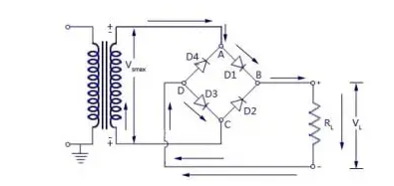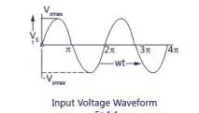

**Fig 3.2:** The Bridge Rectifier

The four diode Full Wave Bridge Rectifier is used due to its added advantage over a Two Diode center-tapped Full-Wave Rectifier as well as a One Diode Half-Wave Rectifier.

The choice of diodes used was based on:

1. The forward current rating: The diode forward current rating is the maximum current that the diode can conduct before failing. The diode is selected in such a way that the current passing through it is less than the forward current rating.
2. The *Peak Inverse Voltage* (PIV) that the diodes would withstand: The peak inverse voltage is the maximum reverse voltage that a diode can withstand without destroying the junction. If the reverse voltage across a diode exceeds this value, the reverse current increases sharply and breaks down the junction due to excessive heat. Peak inverse voltage is extremely important when diode is used as a rectifier. In rectifiers, it has to be ensured that reverse voltage across the diode does not exceed its PIV during the negative half-cycle of input ac voltage. Hence, PIV consideration is generally the deciding factor in diode rectifier circuit. The peak inverse voltage of a rectifier diodes lies between 10V and 10kV depending upon the types of diodes.

25

Vpeak = Vrms



Where *Vrms* is the transformer’s output voltage using the maximum output voltage (that is 12V ac) we have that Vrms = 12V

∴Vpeak = × 12 = 16.97V



For a bridge rectifier, the peak voltage equals the peak inverse voltage. Therefore, the calculated PIV is 16.97V.

Thus, the IN4007 diode was chosen for the rectifier since it satisfies the above stated requirements according to its datasheet.

Voltage drop across diodes = (2 x 0.7) = 1.4V

Voltage drop = 16.97 - 1.4 = 15.57V

Where 0.7 is the forward conducting voltage of a silicon diode.

**3.1.3 The Capacitor Selection**

The filter used in this power supply is a single shunt capacitor. The choice of the filter capacitor depends on:

1. The ripple factor allowed
2. The capacitor breakdown voltage
3. **The Ripple Factor Allowed**

The output of a rectifier consists of a dc component and an AC component (also called ripple). The ripple is undesirable and causes pulsations in the rectified output. The effectiveness of a rectifier depends on the amount of ripple in its output, the smaller this is, the more effective is the rectifier. The ripple factor is an indication of the effectiveness of the filter capacitor and is defined as:

Ripple Factor = = = =



26

The smaller the ripple factor, the lesser the amount of ripples and hence more effective is the rectified output signal. These ripples have a frequency of twice the input supply frequency. The ripple factor for full-wave rectifiers and thus allowed for this project is given as:

IRMS =



IDC =



∴ R = = 0.48



This shows that the DC component of the full-wave rectifier output is more than the ripples, making full wave rectifiers more suitable for rectifying ac to dc.

1. **The Capacitor Breakdown Voltage**

The capacitor breakdown voltage can be determined by applying Kirchhoff’s voltage law at the output of the rectifier to the terminal of the filter capacitor.

Vpeak – 2 (Diode drop (VD)) = Voltage at filter capacitor

For silicon made diode VD ­= 0.7V

∴ VC = 16.97 – 2 (0.7) = 15.57V

Taking a safety factor of two, the capacitor voltage, VC becomes 31.14V, and since this is not a common capacitor voltage, a 25V capacitor was chosen

The capacitance of the capacitor used is gotten using the relationship:

27

Vmax =



IL = load current = 41.60mA (as calculated)

f = frequency = 2 × supply frequency = 2 ×50Hz = 100Hz

C = capacitance

Maximum peak = 11.33V

Obtaining capacitance, we have that: Vmax= = 41.0 x 10-3



2 x 50 x C

11.33 = 41.0 x 10-3

2 x 50 x C

100C = 41.0 x 10-3

11.33

Therefore, C = 41.60 x 10-3 = 0.00003618711F = 36µF

1133

From the calculated value, 36μF is not a standard capacitance value; hence a 1000μF, 25V capacitor was selected. The 47uF capacitor was used to further smoothen the output to reduce the ripples which result in spike current when the theft load is connected to the circuit.

**3.1.4 The Voltage Regulator Selection**

The importance of voltage regulator is to ensure that a fixed voltage output is obtained at the output of the power supply regardless of the variations from the supply input or load connected. The regulation used is the IC voltage regulator LM7805. This implies that a positive fixed +5volts regulator was used to provide the fixed positive voltage level required by the circuitries.

28

The rating of the voltage regulator from the datasheet is as given below:

1. Input voltage range 5~25V
2. Maximum current rating 5mA-1.5A
3. Output voltage range 4.8~30V
4. Operating temperature range 0~125℃

The fixed positive IC voltage regulator was chosen from the 78xx family of fixed positive voltage as they are more efficient in providing the much-needed constant voltages for the interconnected circuitries of the design.

## 3.1.5 Display Unit

This is the unit that the system uses to interact with the user. All the operations and sequences performed by the circuit is displayed on the screen. All instructions to be carried out by the system are also shown on the screen. Also the status of the system is shown on the screen.

This consists of a 16 by 2 data length Liquid Crystal Display screen and its biasing resistors.

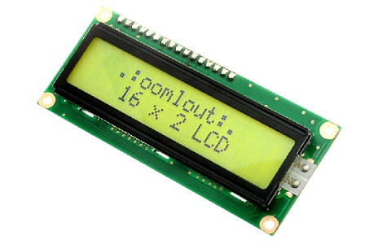

**Figure 3.3:** Schematic diagram of LCD screen.

29

## 

## 3.1.6 HC-SR04 Sensor Unit

An HC-SR04 ultrasonic distance sensor actually consists of two [ultrasonic transducers](https://en.wikipedia.org/wiki/Ultrasonic_transducer).

One acts as a transmitter that converts the electrical signal into 40 KHz ultrasonic sound pulses. The other acts as a receiver and listens for the transmitted pulses. When the receiver receives these pulses, it produces an output pulse whose width is proportional to the distance of the object in front. This sensor provides excellent non-contact range detection between 2 cm to 400 cm (~13 feet) with an accuracy of 3 mm. Since it operates on 5 volts, it can be connected directly to an Arduino or any other 5V logic microcontroller

### **i. Technical Specifications**

|  |  |
| --- | --- |
| Operating Voltage | DC 5V |
| Operating Current | 15mA |
| Operating Frequency | 40KHz |
| Max Range | 4m |
| Min Range | 2cm |
| Ranging Accuracy | 3mm |
| Measuring Angle | 15 degree |
| Trigger Input Signal | 10µS TTL pulse |
| Dimension | 45 x 20 x 15mm |

## 30

## 3.1.7 HC-SR04 Ultrasonic Sensor Pinout

The Ultra Sonic HC-SR04 emits ultrasound at 40,000Hz that travels in the air. If there is an object or obstacle in its path, then it collides and bounces back to the Ultra Sonic module. The formula **distance = speed * time** is used to calculate the distance. Suppose, an object is placed at a distance of 10 cm away from the sensor, the speed of sound in air is 340 m/s or 0.034 cm/µs. It means the sound wave needs to travel in 294 µs. But the Echo pin double the distance (forward and bounce backward distance). So, to get the distance in cm multiply the received travel time value with echo pin by 0.034 and divide it by 2. The distance between Ultra Sonic HC-SR04 and an object is:

distance = (speed * time)/ 2

Speed of Sound:

speed = 340m/s = 0.034cm/us

time = 10 /0.034us = 294us

distance = (speed * time)/2

distance = (0.034 * 294)/2

31

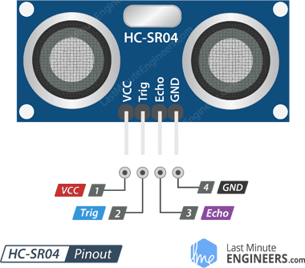

Fig 3.4: Pinout of Ultrasonic Sensor

## 

## 3.1.8 Microcontroller Circuit

This unit comprises the ATmega328 microcontroller and the Analog to Digital Converter (ADC). It controls the transmission of signals to the LCD continuously giving real time data about the water level in the vessel and the pump status. It also transmits signals to the IOT Module which communicates with a Mobile phone.

**3.1.9. Arduino Nano controller**

The Arduino Nano is a small, complete, and breadboard-friendly board based on the ATmega328 (Arduino Nano 3.x). It has more or less the same functionality of the Arduino Duemilanove, but in a different package. It lacks only a DC power jack, and works with a Mini-B USB cable instead of a standard one.

32

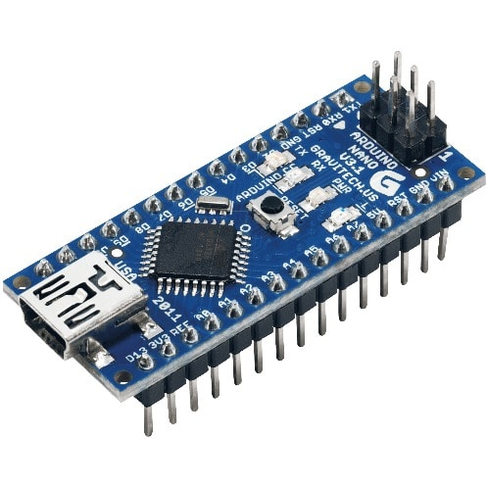

**Figure 3.5:** The circuit diagram of micro controller unit

Essentially, the microcontroller is for programming of all the instruction codes that contains the sequence of operation of the system. The crystal oscillator sets the clock pulse of the system and it associated capacitors. The resistor and capacitors are responsible for resetting the program.

**3.2 IOT Unit**

The HC-06 Bluetooth module is a popular Bluetooth communication module widely used in various IoT projects and applications. It is based on the Bluetooth 2.0 standard and is primarily designed for establishing wireless serial communication between devices. Here are some key details about the HC-06 module:

1. Features:

- Bluetooth Version: The HC-06 module follows the Bluetooth 2.0 specification.

- Serial Communication: It enables transparent serial data communication between a host (such as a microcontroller or a PC) and a Bluetooth-enabled device.

- Slave Mode: The HC-06 module operates in slave mode, allowing it to be paired and controlled by a master device.

33

- Integrated Antenna: The module comes with an on board antenna for wireless communication.

- Simple Configuration: It has a straightforward configuration process, making it easy to use for beginners.

2. Pinout and Connections:

- VCC: Connects to the power supply (typically 3.3V or 5V).

- GND: Ground connection.

- TXD: Transmits data from the module (connects to the RX pin of the host device).

- RXD: Receives data by the module (connects to the TX pin of the host device).

- STATE: Optional pin for indicating the status of the module (e.g., connection status, data transmission).

3. Operating Modes:

- Command Mode: In this mode, the HC-06 module accepts AT commands from the host device for configuration purposes (e.g., changing the device name, baud rate).

- Data Mode: After configuration, the module switches to data mode, where it transfers serial data between the host and the connected device.

4. Pairing and Communication:

- Pairing: The HC-06 module can be paired with a master device (e.g., smartphone, PC) using a PIN code (default: 1234 or 0000).

- Serial Data Transfer: Once paired, the module establishes a serial data link with the master device, allowing bidirectional communication.

**3.2.1 The Switch Unit**

This unit is made up ULN2803 switch and a 12v DC relay, the ULN2803 helps to amplify the signal of the microcontroller into 12v DC to drive the relay which in turns controls the pump.

34

**3.2.2. Selection of relay**

When selecting a 12V DC to 230V AC relay, the key factors to consider include the relay's voltage rating, current rating, contact configuration, and the load requirements. Here's an overview of the key considerations for relay selection:

1. Voltage Rating:

- Ensure that the relay is rated for a DC coil voltage of 12V. This ensures compatibility with your power supply.

2. Current Rating:

- Determine the maximum load current that the relay will switch. This is the current required by the 230V AC load that the relay will control.

- Select a relay with a current rating higher than the maximum load current to ensure it can handle the required switching capacity without overheating.

in this project, the load is a 0.5hp pump motor with a p.f of 0.82

in order to determine its operating current, we need to use the power formula

where

P = IV ----------------------(1)

but the power is in HP and we can convert power in HP to VA using

Real Power (W) = Horsepower (HP) × 746

W = 0.5 x 746 = 373W

Apparent Power (VA) = Real Power (W) / Power Factor (PF)

VA = 373/0.82 = 454.9VA

Hence

from eqn 1

454.9 = I V ---------------------(2)

where

V = 220V which is nominal AC voltage

35

I = 454.9/220 = 2.06Amps

the load current is 2.06Amps

since 2.06A relay is not practically easy to find in the market

Hence a 10Amps relay was chosen which readily available in market

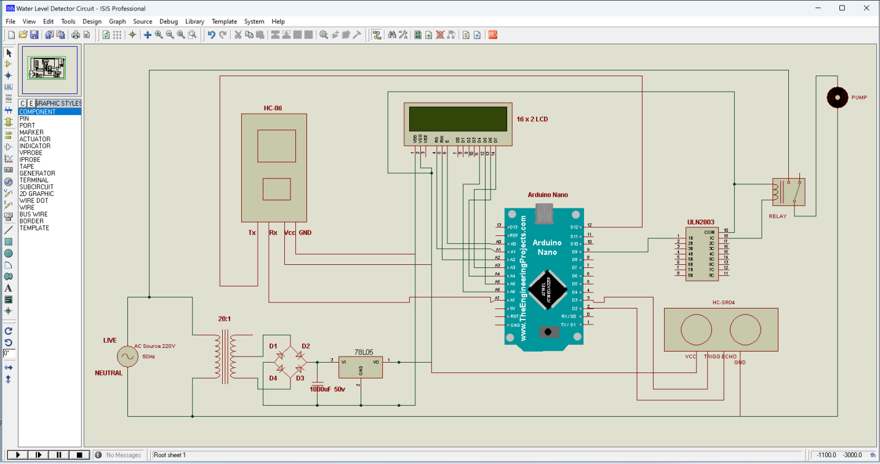

**Figure 3.6:** Complete Circuit Diagram of Water level detection system.

# **3.2.3 Operational Strategy**

The IoT-based ultrasonic sensor water level detector system works by using an ultrasonic sensor to measure the distance between the sensor and the surface of the water in a container. The sensor sends out ultrasonic pulses and measures the time it takes for the pulses to bounce back from the surface of the water. This information is then used to calculate the water level.

36

The system typically consists of the ultrasonic sensor, a microcontroller, and a communication module such as a Wi-Fi module or a cellular module. The micro controller processes the data from the ultrasonic sensor and converts it into a readable format. This data is then transmitted to a cloud-based server using the communication module, where it can be accessed and monitored remotely.

The pump live line is connected through a relay that is being controlled by a ULN2003 switch, the ULN2003 is connected directly to the microcontroller.

The MCU turns on the pump if the level of the tank is below 20% and the temperature is within safe working condition (30 – 50℃).

This operation strategy is programmed in the microcontroller using C language. Appendix A presents the source codes of the microcontroller. The entire operation strategy is shown in Figure 3.6.

# **3.2.4 Simulation**

The simulation was done using Proteus ISIS Professional Design suite. At the heart of the simulation is the programmed microcontroller with inputs from power rails supply.

The input device (Ultrasonic sensor) is being represented by the potentiometers, POT used to simulate levels and temperature while the algorithm performs control on the pump based on the data it gets.

At the output of the microcontroller is an LCD screen, outputs the operations and error messages of the microcontroller.

37

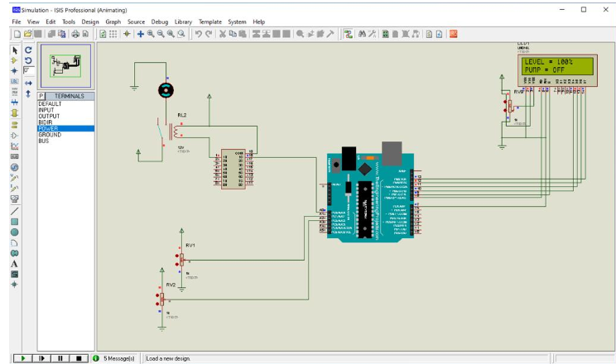

**Figure 3.7:** Screenshot of the Proteus ISIS professional interface.

At the beginning of the simulation, the microcontroller (Figure 3.16) checks whether the DC power switch is closed. If yes, it displays that the system is on and shows real time data of the level and temperature. If the POT is being controlled, the microcontroller reads its value in real time to simulate the operation of the pump.

# **3.2.5 Fabrication**

The components used in the fabrication are resistors, electrolytic capacitors, 5mm LED, buzzer, 7805 voltage regulator IC, ULN2003, IN 4007 Rectifier diodes, ultrasonic sensor

Transistor, Arduino Uno, Appendix D shows the Bill of Engineering Measurement and Evaluation.

38

The prototype control system was constructed using plastic material cut to sizes. It has a dimension of 6cm by 6cm by 6cm. The top was covered with same plastic. The electronic circuit is soldered on the Vero board, which was fixed firmly to the plastic case by means of screws.

The following steps were taken during the construction of the device:

1. the various components were identified;
2. components were connected on the breadboard with the aid of a schematic circuit diagram, after which it was tested and was found working accordingly. Its workability was achieved by connecting the terminals of each component on the breadboard and thereafter checking for continuity;
3. proposed designed was simulated with the Proteus Design Suite to check for its workability before the components are soldered on the Vero board;
4. components were laid out on a Vero board and soldered. Making sure there was no partial contact, dry solder left on the board and tested before fixing it on the casing.

Figure 3.17 shows the layout of the various components of the Vero board; and

1. the module was cased to give it an appealing look as shown in Figure 3.18 and 3.19. The dimension of the case was determined by the size of the Vero board, transformer, contactors and relays.

39

**CHAPTER FOUR**

**TEST, CONSTRUCTION, FINDINGS AND COST**

**4.1 TESTS AND RESULTS**

**TESTS**

The aim of testing is to ascertain that after the design and construction of the entire circuit, it will perform the required function optimally as desired. Three basic tests were carried out and they comprise:

1. Visual inspection test
2. Continuity test
3. Operation test

**Visual Inspection Test**

Visual inspection test was carried out by checking conductor lines, cable termination and components arrangement for faults such as open circuit and short circuit that can be visually detected.

**Continuity Test**

**Procedure of the Continuity Test**: Continuity test was carried out with the aid of a digital multimeter along the paths from the Arduino Uno microcontroller to the LCD, from the Wi-Fi Module to the ATmega8 microcontroller and from the LCD to the *7805* voltage regulator and from the Ultrasonic sensor to the Arduino also from the Temperature sensor to the.

**Result of the Continuity Test**: When continuity test was carried out on the above circuit paths, it was found that continuity failed at certain points along the path. This was rectified by accurate and calm soldering. Accurate display of values on the LCD showed successful continuity from the microcontroller, reception of command data on the specified mobile device showed successful continuity from the Wi-Fi Module, and stability of displayed values showed successful continuity from the voltage regulator to the LCD.

40

**Operation Test**

Operational test was carried out to ensure that the device constructed performed the required function. The operation test was carried out by introducing a power to the system and the expected function was observed.

**Results**

When the entire circuit was visually inspected, short circuited conductor lines were detected. These short circuits were corrected by cutting the open link between the two conductor lines.

When the operation test was carried out, it was seen that the obtained result was exactly as expected of the device, therefore satisfying the cause of the construction.

**4.2 Construction of Mechanical Structure (Casing)**

After the construction of the electronic unit, the construction of the casing commenced. The project was cased so as to give the device a much desired and suitable finishing, protecting the electronic device from environmental condition like moisture, low and high ambient temperature. The casing ensures the reliability of the device by offering mechanical strength to the device.

The casing was constructed out of a very solid 22.8cm by 15.2cm plastic. This gives the required protection and spacing for the LCD display to be mounted.

41

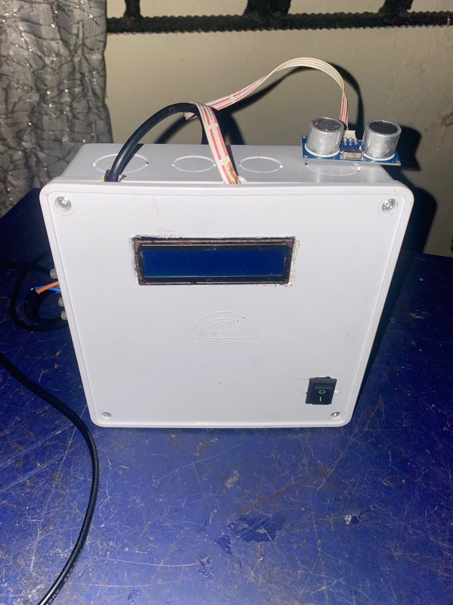

**Fig. 4.1**: Pictorial view of the water level detection system (Control board)

42

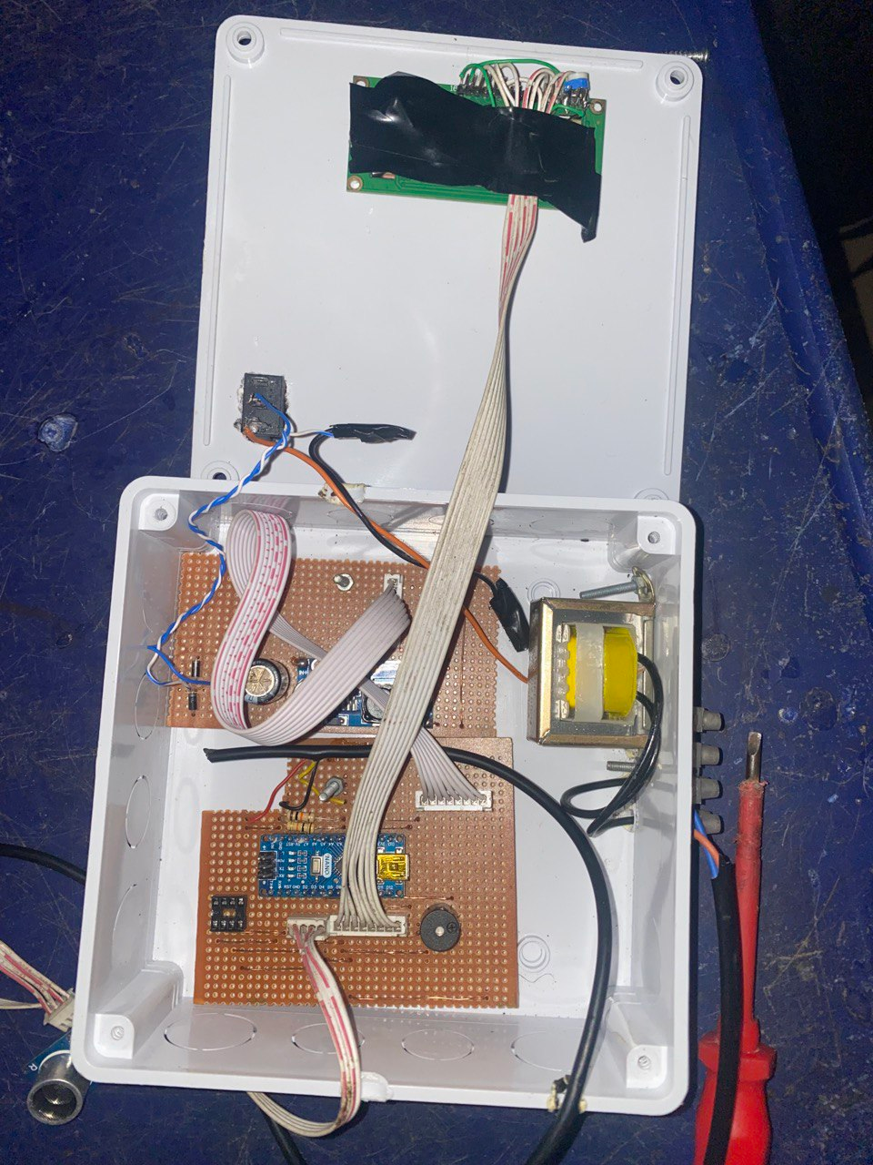

**Fig. 4.2**: Fabricated design showing internal circuitry

43

**4.3 COST ANALYSIS**

The cost analysis of this project work shows that with so very little power consumption and low cost, a reliable water level detection system, can be installed in homes, offices, factories, shops etc to control and enable smooth activities of water supply.

**Table 4.1:** The Cost of the Materials

|  |  |  |  |  |
| --- | --- | --- | --- | --- |
| **S/N** | **DESCRIPTION OF ITEM** | **QTY** | **UNIT PRICE (N)** | **TOTAL PRICE**  **(N)** |
| 1 | 220/12V Transformer | 1 | 600 | 600 |
| 2 | Rectifier diodes IN4007 | 5 | 50 | 250 |
| 3 | Resistor 10k | 9 | 40 | 360 |
| 4 | 25V, 1000micro Farad capacitor  25V, 47micro Farad capacitor | 1  1 | 100  100 | 100  100 |
| 5 | Relay, 12V, 10 A | 1 | 300 | 300 |
| 6 | ATmega8 | 1 | 2000 | 2,000 |
| 7 | Voltage Regulators (LM7805) | 1 | 150 | 150 |
| 8 | Casing | 1 | 1500 | 1,500 |
| 9 | LCD display | 1 | 3600 | 3,600 |
| 10 | Resistors 1k | 2 | 40 | 80 |
| 11 | Connecting belt Wires | 1 | 100 | 100 |
| 12 | 28 pin IC socket | 1 | 30 | 30 |
| 13 | Vero Board | 2 | 200 | 400 |
| 14 | Soldering Led | 1 | 200 | 200 |
| 13 | Vero Board | 2 | 200 | 400 |
| 14 | Soldering Led | 1 | 200 | 200 |
| 15 | Cables | 3 | 50 | 150 |
| 16 | Wifi Module | 1 | 12000 | 12,000 |
| 17 | Power Sockets | 2 | 500 | 1,000 |
| 18 | Temp sensor | 1 | 1000 | 1000 |
| 19 | Pump | 1 | 13,150 | 150 |
| 20 | Power Cords | 2 | 250 | 500 |
|  | **Total** |  |  | **34,670** |
|  |  |  |  |  |

45

**4.4 Findings**

The effectiveness of this experiment depends largely on the similarity and sameness of the

Controller, relays, pump and other circuit components of this experiment.

1. The developed operation strategy of the water level detection system helps to reduce water wastage from overflow of tanks by 100%.

2. The developed operation strategy of this design gives users electric power saving of

66.7% compared to the conventional technique. The energy savings translates into

high monetary benefits, especially with the high cost of utility grid supply in Nigeria.

# **4.5 Contribution to knowledge**

This study has contributed to knowledge in the following ways:

1. A cost-effective operation strategy for automatic water control has been designed;
2. A more reliable water control system for regions with high cost of electricity bill has been developed.
3. Development of the system could prevent water wastage and shortage.
4. Development of a real time monitoring and control for a water system could be realized.

5. Development of sensing system that does not have a direct contact with the water could

be realized.

46

**CHAPTER FIVE**

**CONCLUSION AND RECOMMENDATION**

# **5.1 Conclusion**

An IoT water level detector system is a device that monitors and detects the water level in a tank or reservoir. It typically consists of several components, including a water level sensor, a microcontroller (such as an Arduino or Raspberry Pi), and a communication module (such as Wi-Fi or cellular) that transmits data to a cloud platform.

The water level sensor measures the height of the water and sends the data to the microcontroller. The microcontroller processes the data and uses the communication module to send it to the cloud platform where it can be monitored and analyzed in real-time.

In some cases, the system may also have a control mechanism that can automatically turn on or off a pump or valve to control the flow of water.

The benefits of an IoT water level detector system include real-time monitoring, remote control and automation, and data analysis for informed decision-making. It can be used in various applications such as agriculture, residential, industrial, and commercial.

**5.2 Recommendation**

For further research work, it is recommended that the Arduino Uno device be replaced with Arduino Wido to avoid connection of WiFi devices to send sensor readings to the internet. And an automatic drainage system linked to the Android App operating continuously will do away with human intervention of disposing off the water.

47

# **REFERENCES**

Benelam ,B.& Wyness, L. (2010). Hydration and Health: A Review*. British Nutrition Foundation, Nutrition Bulletin (*pp. 3-25). London, UK: High Holbon House.

Biswas, S., & Iqbal, M. T. (2018). Dynamic Modelling of a Solar Water Pumping System with Energy Storage. *Journal of Solar Energy*, *2018*, 1–12. <https://doi.org/10.1155/2018/8471715>

Bouarfa, S., Vincent, B., Wu, J., Yang, J. & Zimmer, D.(2006). Role of groundwater in irrigation water management in the downstream part of the yellow river. *Irrigation and* Drainage *Systems, 20(1)*, 247-258.

Chaiko, Y., Zhiravecka, A., Kunicina, N, Galkina, A. & Ribickis, L. (2008). Modelling decision making procedure for pump electric drives chosen for water pump stations. *Electronics and Electrical Engineering, 82(2)*, 59-64.

Deb, S., Chakraborty, P., Ghosh, A., Roy, S., Patra, S., & Biswas, D. (2018). Wireless Pump Control with Water Level Monitoring System, *2*(June), 5–10.

Gagandeep, Arora, D., & Saini, H. S. (2018). Design and implementation of an automatic irrigation feedback control system based on monitoring of soil moisture. *Proceedings of the International Conference on Inventive Computing and Informatics, ICICI 2017*, (January), 540–544. <https://doi.org/10.1109/ICICI.2017.8365190>

Gesa, N. (2020). Design and Implementation of a Wireless Fluid Level Display System Using Ultrasonic Sensing Technique, (June). <https://doi.org/10.9734/JERR/2020/v14i117116>

Godwin Premi, M. S., & Malakar, J. (2019). Automatic water tank level and pump control system. *2019 International Conference on Intelligent Computing and Control Systems, ICCS 2019*, (Iciccs), 401–405. <https://doi.org/10.1109/ICCS45141.2019.9065438>

48

Ikponmwosa, O. & Charles, A. (2013). Development of an electric water pump controller and level indicator. *International journal of engineering and applied sciences, 3(2),* 18-21.

Islam, M., & Amjad, M. (2018). Water Automation for Water Pump Controller using Android Application - Survey. *International Journal of Computer Applications*, *182*(29), 34–38. <https://doi.org/10.5120/ijca2018918165>

JAMAL, H. (2016). Logical Automatic Water Control System For Do mestic Applications, (December), 159–162. <https://doi.org/10.15224/978-1-63248-109-2-40>

Jequier, E. & Constant, F. (2010). Water as an essential nutrient: the physiological basis of hydration. *Eur J Clin Nutr, 64 (2)*, 115-123.

Karar, M. E., Al-Rasheed, M. F., Al-Rasheed, A. F., & Reyad, O. (2020). Iot and neural network-based water pumping control system for smart irrigation. *Information Sciences Letters*, *9*(2), 107–112. <https://doi.org/10.18576/isl/090207>

Khairunnas, M. D., Ariyanto, E., & Prabowo, S. (2018). Design and implementation of smart bath water heater using Arduino. *2018 6th International Conference on Information and Communication Technology, ICoICT 2018*, *0*(c), 184–188. <https://doi.org/10.1109/ICoICT.2018.8528772>

Kolesnikov, E. B., Shprekher, D. M., & Malkov, S. B. (2019). Automated system ensuring uninterrupted water supply for small settlements. *Proceedings - 2019 International Ural Conference on Electrical Power Engineering, UralCon 2019*, 13–17. <https://doi.org/10.1109/URALCON.2019.8877676>

Lestariningsih, T., Artono, B., Hidayatullah, N., & Kusbandono, H. (2019). Microcontroller and Android HMI Based Water Level and Control System. *EAI Endorsed Transactions on Internet of Things*, *5*(17), 162807. <https://doi.org/10.4108/eai.28-1-2019.162807>

49

Maurice, M. & Shona, R. (2007). Community Governance for Sustainability: Exploring Benefits of Community Water Schemes. *Local Environment, 12(4)*, 437-445.

Mohd, I. I., Hikmah, N., Azizan, B., Elfadil, N., & Pahang, M. (2020). Design and Development of Microcontroller Based Automatic Fish Feeder System. *Ijesc*, *10*(4), 25380–25383. Retrieved from <http://ijesc.org/>

Momin, S. A., Roy, P., Kader, G., Hasan, S., & Islam, S. (2016). Construction of Digital Water Level Indicator and Automatic Pump Controlling System, *03*(October), 1–5.

Nasir, I. A., Alkhadafe, H., & Mohammed, K. (2018). PIC Microcontroller Based Water level Monitoring and Controlling System using Sharp Infra-red range sensor, *17*(1), 407–412.

Oloyede, A. (2017). Development of a Microcontroller Based Automatic Water Pumping Machine Development of a Microcontroller Based Automatic Water Pumping. In *Proceedings of the International Conference on Inventive Computing and Informatics, ICICI 2017 of the iSTEAMS Multidisciplinary Cross-Border Conference University of Ghana* (pp. 255–264).

OO, A. (2020). Design, simulation and implementation of an Arduino microcontroller based automatic water level controller with I2C LCD display. *International Journal of Advances in Applied Sciences*, *9*(2), 77. <https://doi.org/10.11591/ijaas.v9.i2.pp77-84>

Pathan, S., Kumar, P., Tendolkar, S., Patil, V., Lucas, S., & Daithankar, A. (2016). Automatic control of a pump system for water level using Microcontroller and LabVIEW TM. *International Research Journal of Engineering and Technology*, 2395–56. Retrieved from <https://www.irjet.net/archives/V3/i5/IRJET-V3I5553.pdf>

Popkin, B.M., D'Anci, K. E., & Rosenberg, I. H. (2010). Water, hydration, and health. *Nutr Rev, 68(8)*, 439-458.

50

Prakosa, J. A., Putov, A. V, & Stotckaia, A. D. (2019). Measurement Uncertainty of Closed Loop Control System for Water Flow Rate. *2019 XXII International Conference on Soft Computing and Measurements (SCM))*, 60–63.

Prima, E. C., Munifaha, S. S., Salam, R., Aziz, M. H., & Suryani, A. T. (2017). Automatic Water Tank Filling System Controlled Using ArduinoTM Based Sensor for Home Application. *Procedia Engineering*, *170*, 373–377. <https://doi.org/10.1016/j.proeng.2017.03.060>

Ruan, X., Ma, Q., Lv, X., Liu, D., & Zhang, B. (2017). Design and experimental study on the automatic speed control system of a pneumatic submersible pump. *Journal of Engineering Science and Technology Review*, *10*(4), 25–30. <https://doi.org/10.25103/jestr.104.04>

Saha, D., Mukherjee, I., Roy, J., & Chatterjee, S. (2019). Microcontroller Based Water Level Indicator And Controller System. *International Journal of Computer Sciences and Engineering*, *7*(10), 164–167. <https://doi.org/10.26438/ijcse/v7i10.164167>

Vikram, S., Gosain, A. K., Datta, P. S., & Diwan, S. (2009). A new scheme for large-scale natural water storage in the floodplains: the Delhi Yamuna floodplains as a case study. *Current Science, 96 (10)*. 1338-1341.

Zhang, H., Wang, H., Li, Z. W., & Zhang, R. Q. (2019). Design of Monitor and Control System of Experimental Facility for Oil-Gas-Water Multi-phase Flow Loop. *2019 5th International Conference on Control, Automation and Robotics, ICCAR 2019*, 817–820. <https://doi.org/10.1109/ICCAR.2019.8813407>

1. Soni, “Smart Well Monitoring System,” *2018 Int. Conf. Smart City Emerg. Technol.*, pp. 1–5.

S. Jadhav, “Monitoring of Industrial Water Usage by using Internet of Things,” *2018 Int. Conf. Inf. , Commun. Eng. Technol.*, pp. 1–4, 2018.

51

Y. Li, Y. Wang, M. Cong, and H. Lang, “Design and Development of a water quality monitoring network and system,” pp. 1–5.

R. Shevale, “IOT Based Real time water Monitoring System for Smart City,” vol. 3, no. 4, pp. 246–251, 2018.

https://unesdoc.unesco.org/ark:/48223/pf0000372876.locale=en

https://en.wikipedia.org/wiki/Water_scarcity

https://en.wikipedia.org/wiki/Smart_Cities_Mission

S. Kim and H. Kim, “Optimal Design of an Overlapped Ultrasonic Sensor Ring Using a New Composite Design Index,” 2012.

G. Suciu, A. Vintea, S. C. Arseni, C. Butca, and V. Suciu, “Challenges and Solutions for Advanced Sensing of Water Infrastructures in Urban Environments,” pp. 349–352, 2015.

J. Priya and S. Chekuri, “WATER LEVEL MONITORING SYSTEM USING IOT,” pp. 1813–1817, 2017.

M. Javanmard and F. Arvin, “A Microcontroller-Based Monitoring System for Batch Tea Dryer,” pp. 101–106, 2009.

B. Dhivyapriya, C. Gulabsha, S. P. Maniprabha, G. Kandasamy, and V. Chandrasekaran, “GSM BASED WATER TANK LEVEL MONITORING AND PUMP CONTROL,” pp. 108–112, 2016.

S. S. M. S. Notification, “Automatic Water Level Controller with Short Messaging,” vol. 4, no. 9, pp. 1–4, 2014.

M. K. Reza, S. A. Tariq, and S. M. M. Reza, “Microcontroller Based Automated Water Level Sensing and Controlling: Design and Implementation Issue,” vol. I, 2010.

52

M. Saraswati, E. Kuantama, and P. Mardjoko, “Design and Construction of Water Level Management system Accessible Through SMS,” 2012, doi: 10.1109/EMS.2012.60.

Networks, S. Maqbool, and N. Chandra, “Real Time Wireless

Monitoring and Control of Water Systems using Zigbee,” pp. 2–7, 2013, doi: 10.1109/CICN.2013.42.

1. Hartmanis and J. Van Leeuwen, *Lecture Notes in Computer Science*. .

P. Damor and K. J. Sharma, “International Journal of Advance Engineering and Research Development IoT based Water Monitoring System : A Review,” pp. 1–6, 2017.

C. Engineering, “THE REAL TIME MONITORING OF WATER QUALITY IN IoT ENVIRONMENT,” 2015.

A. Roy, K. P. Singh, and A. Kumar, “AUTOMATIC WATER LEVEL INDICATOR USING ULTRASONIC SENSOR AND GSM,” no. 5, pp. 269, 2018.

J. Bhatt and J. Patoliya, “Iot based water quality monitoring system 1 1,” no. 4, pp. 44–48, 2016.

“PROTOTYPE OF WATER LEVEL DETECTION SYSTEM,” no. March, 2016.

O. Mahfooz, M. Memon, and A. Iftikhar, “Project Review on Water Level Sensing Using PLC,” vol. 2, no. 2, pp. 160–170, 2012.

P. Verma *et al.*, “Towards an IoT Based Water Management System for a Campus.”

T. Perumal, N. Sulaiman, and C. Y. Leong, “Internet of Things ( IoT ) Enabled Water Monitoring System,” pp. 86–87, 2015.

R. Raghavendra, “Implementation of Simulated Water Level Controller,” vol. 3, no. 11, pp. 328–332, 2013.

53

# **APPENDIX A Overview of Arduino Core Processor**



54

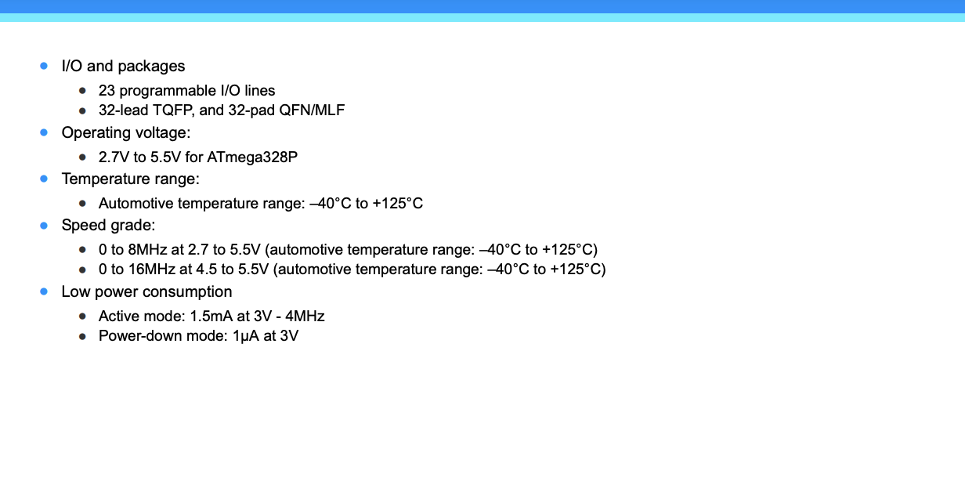

55

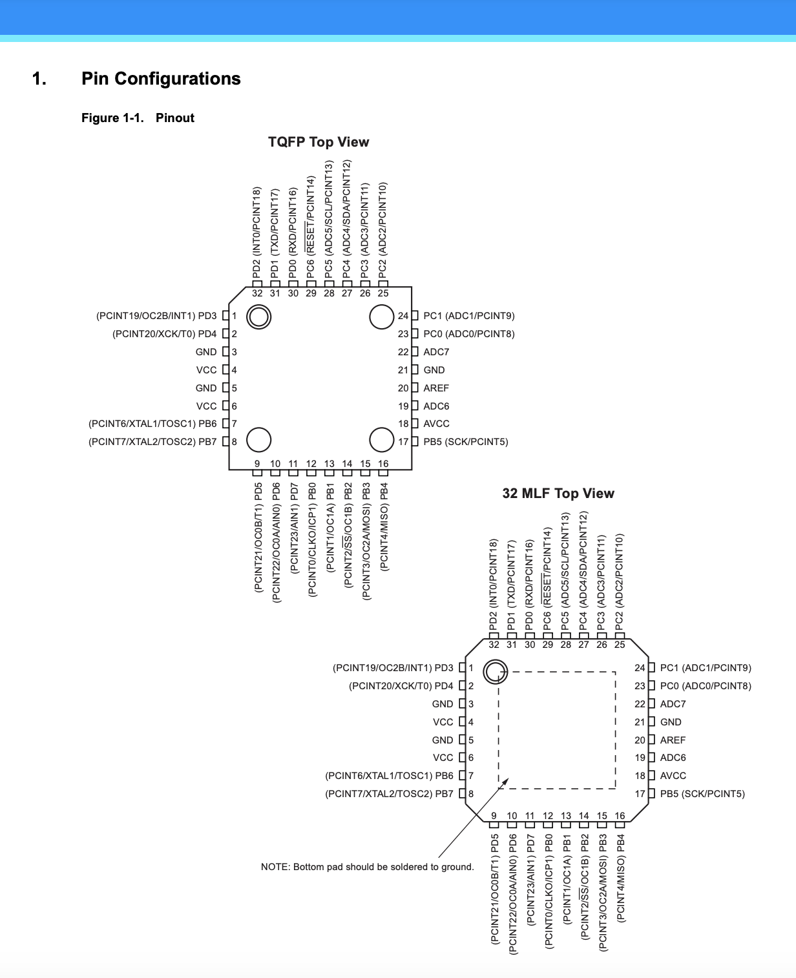

56

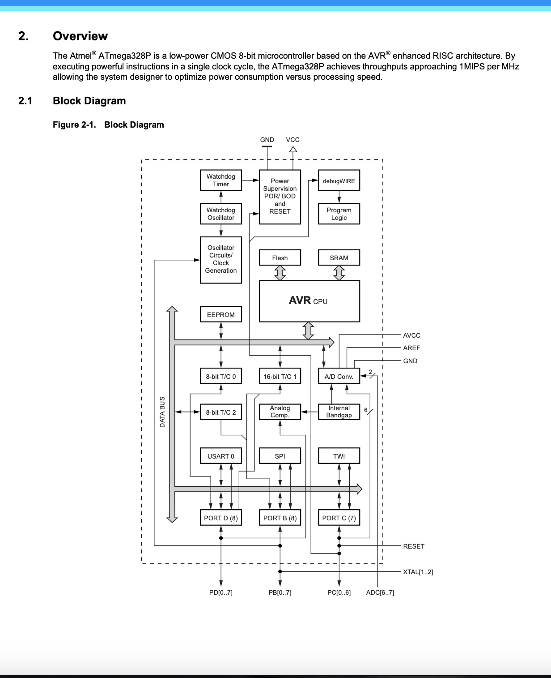

57

# APPENDIX B Specifications for Ultrasonic Sensor

Pin Layout

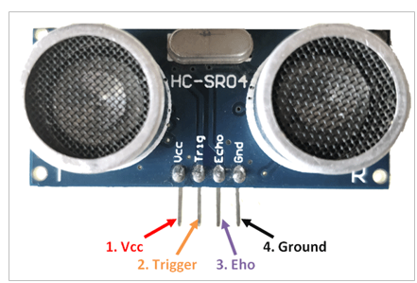

Technical specification

HC – SR04 Sensor Features

* Operating voltage: +5V
* Theoretical Measuring Distance: 2cm to 450cm
* Practical Measuring Distance: 2cm to 80cm
* Accuracy: 3mm
* Measuring angle covered: < 15°
* Operating Current: < 15mA
* Operating Frequency: 40Hz

58

# **APPENDIX C Micro-controller source code**

#include < Liquid Crystal. h>

Liquid Crystal lcd (8, 9, 10, 11, 12, 13);

//Global Function names

void Pump Controller(void);

void TURN_ON_RELAY(void);

void TURN_OFF_RELAY(void);

const int L, Sensor = A1;

cons, int T, Sensor = A2;

//Global Variables Declaration

double Height = 0;

double Temp = 0;

const int RELAY = A0;

char data = 'H';

String PUMP_STATUS = "OFF";

void loop(void)

{

 Height = (analog Read (L, Sensor) * 100.0)/1023.0;

 Temp = (analog Read (T, Sensor) * 100.0)/1023.0;

59

  lcd.set Cursor (0,0);

  lcd.print ("LEVEL = ");

  lcd.set Cursor (8,0);

  lcd.print (Height);

  lcd.set Cursor (14,0);

  lcd.print ("cm");

 lcd.set Cursor (0,1);

 lcd.print ("TEMP = ");

 lcd.set Cursor (9,1);

 lcd.print (Temp);

 lcd.set Cursor (14,1);

 lcd.print ("'C");

    if (Serial available ()>0)//Listens for phone command from the HC-06 Bluetooth module

    {

      data = Serial.read();

      if(data=='D'||data=='d')

      {

        Serial .print ln ("  ");

         Serial. Print ln ("********************************");

        Serial. Print ln ("WATER LEVEL:");

        Serial. Print ln (Height);

        Serial. Print ln ("********************************");

        Serial. Print ln ("Pump Temperature:");

        Serial .print ln (Temp);

        Serial. Print ln ("********************************");

        Serial. Print ("Pump is:");

        Serial. print ln (PUMP_STATUS);

59

Serial. Print ln ("********************************");

        Serial. print ln ("  ");

        Serial. print ln ("  ");

        Serial. print ln ("  ");

      }

    }

 if((Height<40) &&(Temp<60))

 {

      Digital Write (RELAY, HIGH);

      PUMP_STATUS = "ON";

 } else if(Height>=99||Temp>60||data=='s'||data=='S')

 {

     Digital Write (RELAY, LOW);

     PUMP_STATUS = "OFF";

 }

  }

void TURN_ON_RELAY(void)

{

  Digital Write (RELAY, HIGH);

}

void TURN_OFF_RELAY(void)

{

  Digital Write (RELAY, LOW);

}

void setup(void)

{

  lcd. Begin (16,2);

  pin Mode (RELAY, OUTPUT);

  60

pin Mode (L Sensor, INPUT);

  pin Mode (T, Sensor, INPUT);

  Serial begin (9600);}

# **APPENDIX D Bill of Engineering Measurement and Evaluation**

Table D1: Bill of Engineering Measurement and Evaluation as at December, 2022.

|  |  |  |  |  |
| --- | --- | --- | --- | --- |
| **S/N** | **Item** | **Quantity** | **Unit Cost (₦)\*** | **Total (₦)\*** |
| 1 | Standard Resistors | 15 | 10 | 150 |
| 2 | Variable Resistors | 24 | 25 | 600 |
| 3 | Electrolytic capacitors | 6 | 40 | 240 |
| 4 | 5mm LED | 2 | 10 | 20 |
| 5 | Buzzer | 1 | 250 | 250 |
| 6 | 7805 Positive voltage regulator | 1 | 100 | 100 |
| 7 | Ultrasonic Sensor | 5 | 120 | 600 |
| 8 | HC-06 Bluetooth module | 3 | 200 | 600 |
| 9 | IN 4007 Rectifier diodes | 24 | 20 | 480 |
| 10 | Arduino Nano | 1 | 12000 | 12000 |
| 11 | ULN28003 | 1 | 1000 | 1000 |
| 12 | 16 X 2 LCD display. | 1 | 2000 | 2000 |
| 13 | BC 547 NPN Transistor | 5 | 150 | 750 |
| 14 | 12 MHz Crystal Oscillator  Piezoelectric device | 1 | 50 | 50 |
| 15 | 12 V, 3 A DC coil Relay | 4 | 350 | 1400 |
| 16 | Pipe | 1 length | 5000 | 5000 |
| 17 | Frame Structure | 1 | 35000 | 35000 |
| 18 | Tank | 2 | 2000 | 4000 |
| 19 | Screws |  |  | 600 |
| 20 | Glue |  |  | 100 |
| 21 | Vero board | 2 | 250 | 500 |
| 22 | Lead | 1 Roll | 2500 | 2500 |
|  | **Total** |  |  | **27,290** |

62